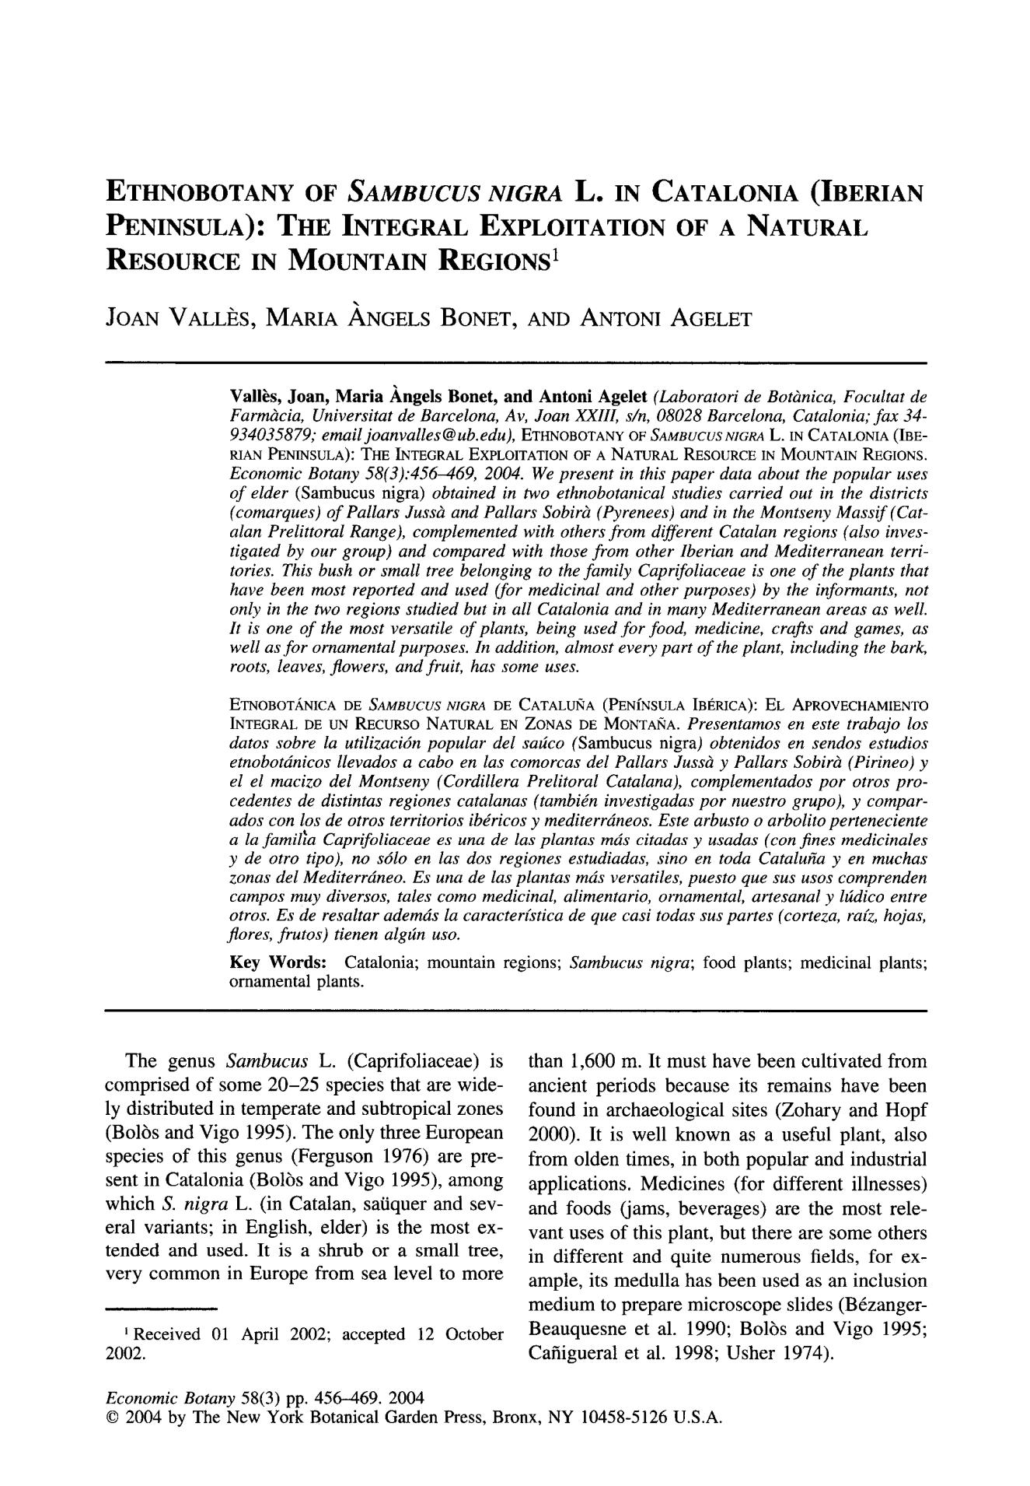

**ETHNOBOTANY OF *SAMBUCUS NIGRA* L. IN CATALONIA (IBERIAN PENINSULA): THE INTEGRAL EXPLOITATION OF A NATURAL RESOURCE IN MOUNTAIN REGIONS 1**

JOAN VALLI~S, MARIA ANGELS BONET, AND ANTONI AGELET

Vall~s, **Joan, Maria Angels Bonet, and Antoni Agelet** *(Laboratori de Bot&nica, Focultat de*

*Farmglcia, Universitat de Barcelona, Av, Joan XXIII, s/n, 08028 Barcelona, Catalonia; f a x 34-*

*934035879; emailjoanvalles@ub.edu),* ETHNOBOTANYOF *SAMBUCUSNIGeA* L. IN CATALONIA(IBE-

RIANPENINSULA):THE INTEGRALEXPLOITATIONOF A NATURALRESOURCEIN MOUNTAINREGIONS.

*Economic Botany 58(3):456-469, 2004. We present in this paper data about the popular uses o f elder* (Sambucus nigra) *obtained in two ethnobotanical studies carried out in the districts (comarques) o f Pallars Jussgl and Pallars Sobirgt (Pyrenees) and in the Montseny Massif(Cat - alan Prelittoral Range), complemented with others fro m different Catalan regions (also inves-tigated by our group) and compared with those f r o m other Iberian and Mediterranean terri-tories. This bush or small tree belonging to the family Caprifoliaceae is one o f the plants that have been most reported and used (for medicinal and other purposes) by the informants, not only in the two regions studied but in all Catalonia and in many Mediterranean areas as well. It is one o f the most versatile o f plants, being used f o r food, medicine, crafts and games, as well as f o r ornamental purposes. In addition, almost every part o f the plant, including the bark, roots, leaves, flowers, and fruit, has some uses.*

ETNOBOT,/~NICA DE *8AMBUCUS NIGRA* DE CATALUIqA (PENfNSULA IBERICA): EL APROVECHAMIENTO INTEGRAL DE UN RECURSO NATURAL EN ZONAS DE MONTAIqA. *Presentamos* *e n e s t e* *trabajo los*

*datos sobre la utilizaci6n popular del satico* (Sambucus nigra) *obtenidos en sendos estudios etnobotdnicos llevados a cabo en las comorcas del Pallars Juss~ y Pallars Sobirgl (Pirineo) y el el macizo del Montseny (Cordillera Prelitoral Catalana), complementados po r otros pro-cedentes de distintas regiones catalanas (tambign investigadas po r nuestro grupo), y compar-ados con los de otros territorios ibgricos y mediterrdneos. Este arbusto o arbolito perteneciente a la famil~a Caprifoliaceae es una de las plantas rods citadas y usadas (con fines medicinales y de otro tipo), no s6lo en las dos regiones estudiadas, sino en toda Catalu~a y e n muchas zonas del Mediterrdneo. Es una de las plantas mds versatiles, puesto que sus usos comprenden campos muy diversos, tales como medicinal alimentario, ornamental artesanal y hMico entre otros. Es de resaltar ademds la caracterfstica de que casi todas sus partes (corteza, ra[z, hojas, flores, frutos) tienen algtin uso.*

Key Words: Catalonia; mountain regions; *Sambucus nigra;* food plants; medicinal plants; ornamental plants.

The genus *S a m b u c u s* L. (Caprifoliaceae) is comprised of some 20 - 2 5 species that are wide-ly distributed in temperate and subtropical zones (Bolrs and Vigo 1995). The only three European species of this genus (Ferguson 1976) are pre-sent in Catalonia (Bolrs and Vigo 1995), among which *S. n i g r a* L. (in Catalan, saiiquer and sev-eral variants; in English, elder) is the most ex-tended and used. It is a shrub or a small tree, very common in Europe from sea level to more

~Received 01 April 2002; accepted 12 October 2002.

than 1,600 m. It must have been cultivated from ancient periods because its remains have been found in archaeological sites (Zohary and Hopf 2000). It is well known as a useful plant, also from olden times, in both popular and industrial applications. Medicines (for different illnesses) and foods (jams, beverages) are the most rele-vant uses of this plant, but there are some others in different and quite numerous fields, for ex-ample, its medulla has been used as an inclusion medium to prepare microscope slides (Brzanger-Beauquesne et al. 1990; Bolrs and Vigo 1995; Cafiigueral et al. 1998; Usher 1974).

*Economic Botany* 58(3) pp. 456--469. 2004

9 2004 by The New York Botanical Garden Press, Bronx, NY 10458-5126 U.S.A.

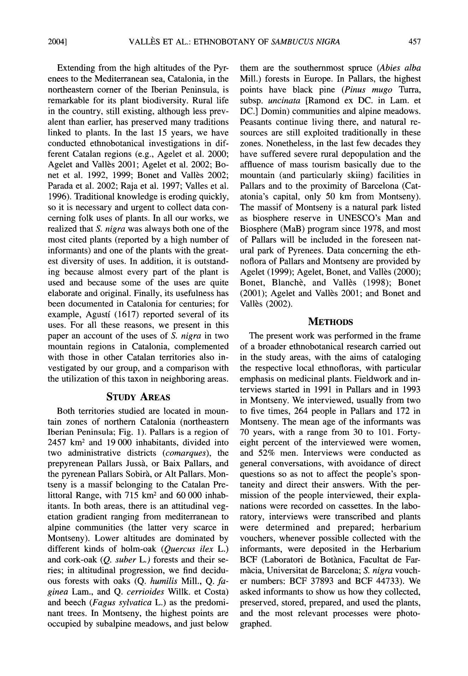2004] VALLI~SET AL.: ETHNOBOTANYOF *SAMBUCUSNIGRA* 457

Extending from the high altitudes of the Pyr-enees to the Mediterranean sea, Catalonia, in the northeastern corner of the Iberian Peninsula, is remarkable for its plant biodiversity. Rural life in the country, still existing, although less prev-alent than earlier, has preserved many traditions linked to plants. In the last 15 years, we have conducted ethnobotanical investigations in dif-ferent Catalan regions (e.g., Agelet et al. 2000; Agelet and Vallbs 2001; Agelet et al. 2002; Bo-net et al. 1992, 1999; Bonet and Vall~s 2002; Parada et al. 2002; Raja et al. 1997; Valles et al. 1996). Traditional knowledge is eroding quickly, so it is necessary and urgent to collect data con-cerning folk uses of plants. In all our works, we realized that *S. nigra* was always both one of the most cited plants (reported by a high number of informants) and one of the plants with the great-est diversity of uses. In addition, it is outstand-ing because almost every part of the plant is used and because some of the uses are quite elaborate and original. Finally, its usefulness has been documented in Catalonia for centuries; for example, Agustf (1617) reported several of its uses. For all these reasons, we present in this paper an account of the uses of *S. nigra* in two mountain regions in Catalonia, complemented with those in other Catalan territories also in-vestigated by our group, and a comparison with the utilization of this taxon in neighboring areas.

**STUDY AREAS**

Both territories studied are located in moun-tain zones of northern Catalonia (northeastern Iberian Peninsula; Fig. 1). Pallars is a region of 2457 krn z and 19 000 inhabitants, divided into two administrative districts *(comarques),* the prepyrenean Pallars Jussh, or Baix Pallars, and the pyrenean Pallars Sobirh, or Alt Pallars. Mon-tseny is a massif belonging to the Catalan Pre-littoral Range, with 715 km 2 and 60 000 inhab-itants. In both areas, there is an attitudinal veg-etation gradient ranging from mediterranean to alpine communities (the latter very scarce in Montseny). Lower altitudes are dominated by different kinds of holm-oak *(Quercus ilex* L.) and cork-oak *(Q. suber* L.) forests and their se-ries; in altitudinal progression, we find decidu-ous forests with oaks (Q. *humilis* Mill., Q. *fa-ginea* Lam., and Q. *cerrioides* Willk. et Costa)and beech *(Fagus sylvatica* L.) as the predomi-nant trees. In Montseny, the highest points are occupied by subalpine meadows, and just below

them are the southernmost spruce *(Abies alba* Mill.) forests in Europe. In Pallars, the highest points have black pine *(Pinus mugo* Turra, subsp, *uncinata* [Ramond ex DC. in Lam. et DC.] Domin) communities and alpine meadows. Peasants continue living there, and natural re-sources are still exploited traditionally in these zones. Nonetheless, in the last few decades they have suffered severe rural depopulation and the affluence of mass tourism basically due to the mountain (and particularly skiing) facilities in Pallars and to the proximity of Barcelona (Cat-atonia's capital, only 50 km from Montseny). The massif of Montseny is a natural park listed as biosphere reserve in UNESCO's Man and Biosphere (MaB) program since 1978, and most of Pallars will be included in the foreseen nat-ural park of Pyrenees. Data concerning the eth-noflora of Pallars and Montseny are provided by Agelet (1999); Agelet, Bonet, and Vall~s (2000); Bonet, Blanche, and Vall~s (1998); Bonet (2001); Agelet and Vall~s 2001; and Bonet and Vall6s (2002).

**METHODS**

The present work was performed in the frame of a broader ethnobotanical research carried out in the study areas, with the aims of cataloging the respective local ethnofloras, with particular emphasis on medicinal plants. Fieldwork and in-terviews started in 1991 in Pallars and in 1993 in Montseny. We interviewed, usually from two to five times, 264 people in Pallars and 172 in Montseny. The mean age of the informants was 70 years, with a range from 30 to 101. Forty-eight percent of the interviewed were women, and 52% men. Interviews were conducted as general conversations, with avoidance of direct questions so as not to affect the people's spon-taneity and direct their answers. With the per-mission of the people interviewed, their expla-nations were recorded on cassettes. In the labo-ratory, interviews were transcribed and plants were determined and prepared; herbarium vouchers, whenever possible collected with the informants, were deposited in the Herbarium BCF (Laboratori de Botgnica, Facultat de Far-m~cia, Universitat de Barcelona; *S. nigra* vouch-er numbers: BCF 37893 and BCF 44733). We asked informants to show us how they collected, preserved, stored, prepared, and used the plants, and the most relevant processes were photo-graphed.

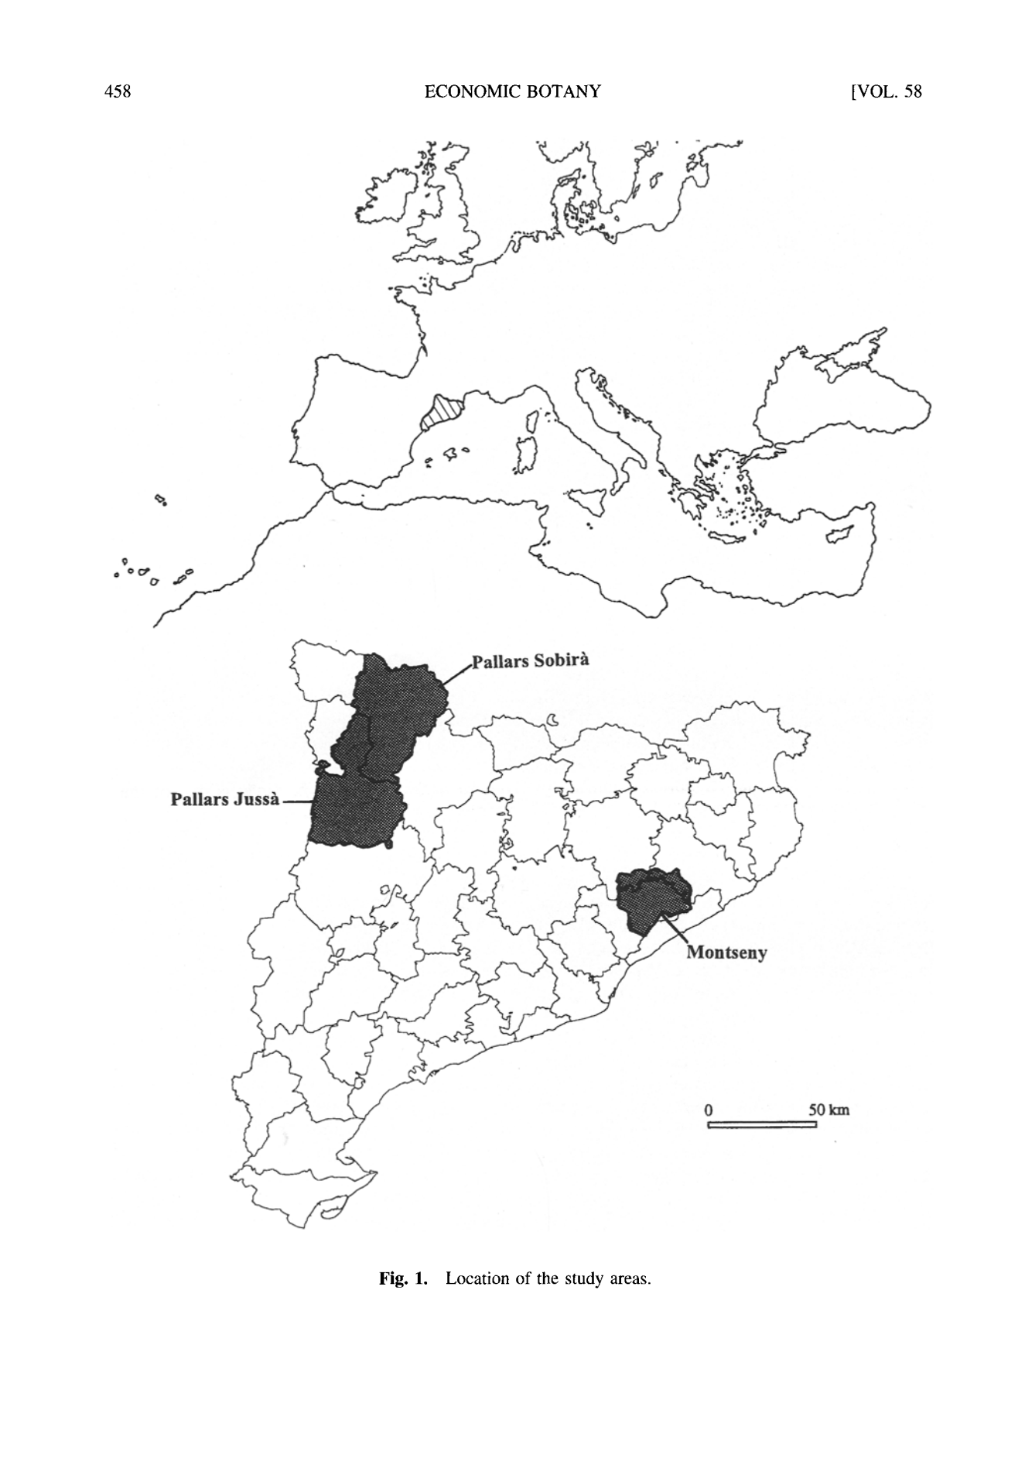458 ECONOMIC BOTANY [VOL. 58

Fig. 1. Location of the study areas.

|  |  |  |  |
| --- | --- | --- | --- |
| 2004] | VALLI~S ET AL.: ETHNOBOTANY OF *SAMBUCUSNIGRA* | | 459 |
|  | **RESULTS AND DISCUSSION** | **MEDICINAL USES** |  |

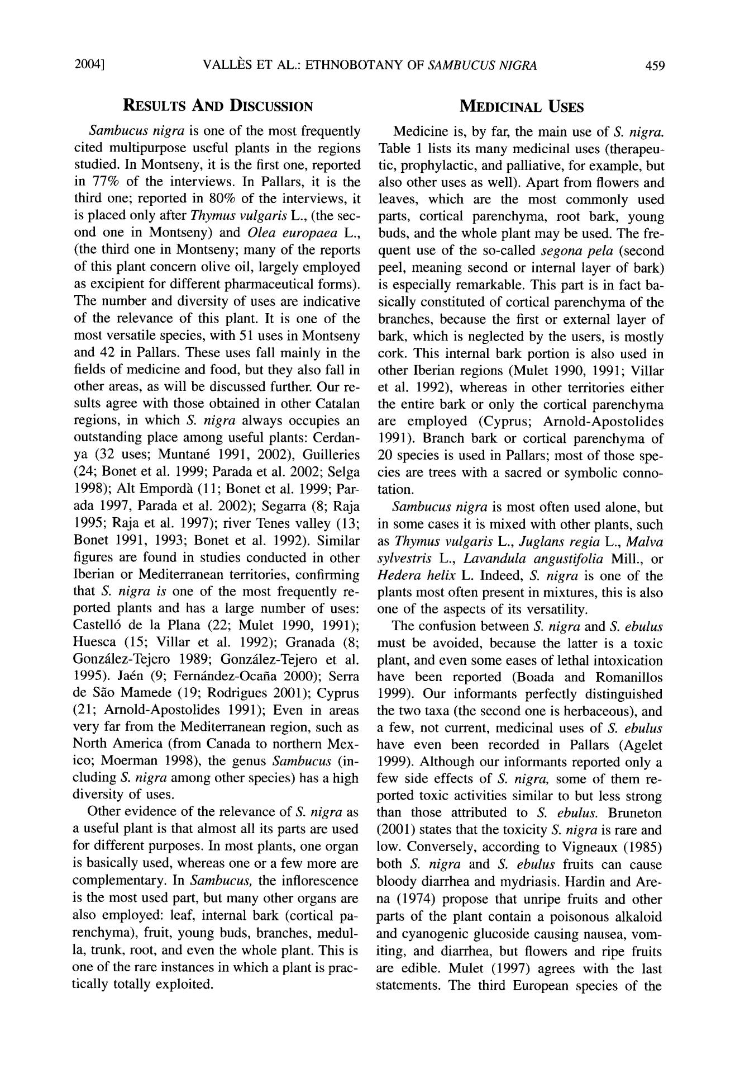

*Sambucus nigra* is one of the most frequentlycited multipurpose useful plants in the regions studied. In Montseny, it is the first one, reported in 77% of the interviews. In Pallars, it is the third one; reported in 80% of the interviews, it is placed only after *Thymus vulgaris* L., (the sec-ond one in Montseny) and *Olea europaea L.,* (the third one in Montseny; many of the reports of this plant concern olive oil, largely employed as excipient for different pharmaceutical forms). The number and diversity of uses are indicative of the relevance o f this plant. It is one of the most versatile species, with 51 uses in Montseny and 42 in Pallars. These uses fall mainly in the fields of medicine and food, but they also fall in other areas, as will be discussed further. Our re-sults agree with those obtained in other Catalan regions, in which *S. nigra* always occupies an outstanding place among useful plants: Cerdan-ya (32 uses; Muntan~ 1991, 2002), Guilleries (24; Bonet et al. 1999; Parada et al. 2002; Selga 1998); Alt Empord?a (11; Bonet et al. 1999; Par-ada 1997, Parada et al. 2002); Segarra (8; Raja 1995; Raja et al. 1997); fiver Tenes valley (13; Bonet 1991, 1993; Bonet et al. 1992). Similar figures are found in studies conducted in other Iberian or Mediterranean territories, confirming that *S. nigra is* one of the most frequently re-ported plants and has a large number o f uses: Castell6 de la Plana (22; Mulet 1990, 1991); Huesca (15; Villar et al. 1992); Granada (8; Gonzfilez-Tejero 1989; Gonzfilez-Tejero et al. 1995). Ja6n (9; Fernfindez-Ocafia 2000); Serra de Silo Mamede (19; Rodrigues 2001); Cyprus (21; Arnold-Apostolides 1991); Even in areas very far from the Mediterranean region, such as North America (from Canada to northern Mex-ico; Moerman 1998), the genus *Sambucus* (in-cluding *S. nigra* among other species) has a high diversity of uses.

Other evidence o f the relevance of *S. nigra* as a useful plant is that almost all its parts are used for different purposes. In most plants, one organ is basically used, whereas one or a few more are complementary. In *Sambucus,* the inflorescence is the most used part, but many other organs are also employed: leaf, internal bark (cortical pa-renchyma), fruit, young buds, branches, medul-la, trunk, root, and even the whole plant. This is one of the rare instances in which a plant is prac-tically totally exploited.

Medicine is, by far, the main use of *S. nigra.* Table 1 lists its many medicinal uses (therapeu-tic, prophylactic, and palliative, for example, but also other uses as well). Apart from flowers and leaves, which are the most commonly used parts, cortical parenchyma, root bark, young buds, and the whole plant may be used. The fre-quent use of the so-called *segona pela* (second peel, meaning second or internal layer of bark) is especially remarkable. This part is in fact ba-sically constituted of cortical parenchyma o f the branches, because the first or external layer o f bark, which is neglected by the users, is mostly cork. This internal bark portion is also used in other Iberian regions (Mulet 1990, 1991; Villar et al. 1992), whereas in other territories either the entire bark or only the cortical parenchyma are employe d (Cyprus; Arnold - Apostolides 1991). Branch bark or cortical parenchyma of 20 species is used in Pallars; most of those spe-cies are trees with a sacred or symbolic conno-tation.

*Sambucus nigra* is most often used alone, butin some cases it is mixed with other plants, such as *Thymus vulgaris L., Juglans regia L., Malva* *sylvestris L., Lavandula angustifolia* Mill., or *Hedera helix* L. Indeed, *S. nigra* is one of theplants most often present in mixtures, this is also one of the aspects of its versatility.

The confusion between *S. nigra* and *S. ebulus* must be avoided, because the latter is a toxic plant, and even some eases of lethal intoxication have been reported (Boada and Romanillos 1999). Our informants perfectly distinguished the two taxa (the second one is herbaceous), and a few, not current, medicinal uses of *S. ebulus* have even been recorded in Pallars (Agelet 1999). Although our informants reported only a few side effects o f *S. nigra,* some of them re-ported toxic activities similar to but less strong than those attributed to *S. ebulus.* Bruneton (2001) states that the toxicity *S. nigra* is rare and low. Conversely, according to Vigneaux (1985) both *S. nigra* and *S. ebulus* fruits can cause bloody diarrhea and mydriasis. Hardin and Are-na (1974) propose that unripe fruits and other parts of the plant contain a poisonous alkaloid and cyanogenic glucoside causing nausea, vom-iting, and diarrhea, but flowers and ripe fruits are edible. Mulet (1997) agrees with the last statements. The third European species of the

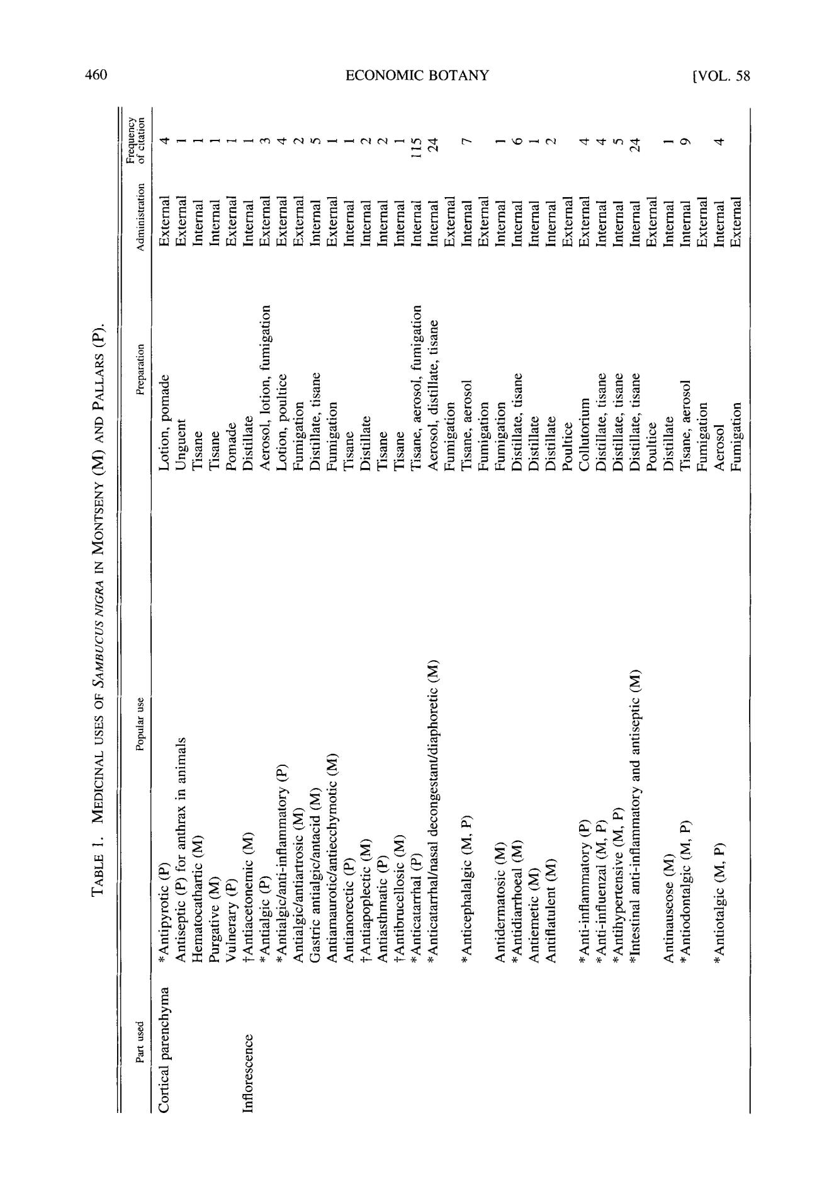**460** **ECONOMIC BOTANY** **[VOL. 58**

o o

<

0 0

|  |  |  |  |  |  |  |  |  |
| --- | --- | --- | --- | --- | --- | --- | --- | --- |
| < |  | ~= |  | ~=~ |  |  |  |  |
|  |  |  |  |  |  |  |  |
| ,,..j |  | **o.=** | **~** | **~.~ ~** |  |  |  |  |
| < |  |  |  |  |  |
| ,,-1 |  |  |  |  |  |  |  |  |
|  | 0 |  |  | **E** '="= | | | "= |  |
|  |  |  | o ~ | ~ | ~ |  |  |
|  |  |  |  |  |  |
| Z |  |  |  |  |  |  |  |  |
| < |  |  |  | ~ | . ~ | . ~ | .,-~ '.,~ |  |
|  | **~ N N a .** | o0 |  |  |  |  | **~ u. < u.** |  |
|  |  |  |  |  |  |  |

z

[ . ,

Z

9

**z**

|  |  |  |
| --- | --- | --- |
| cr~ | o |  |
| ~2 |  |
| 9 |  |
|  |  |
|  | 9 |  |
| ,..-1 |  |  |
| < | " 0 |  |
| **z** |  |  |

,..4

~'~.Q

<

$$

**E**

o

t~

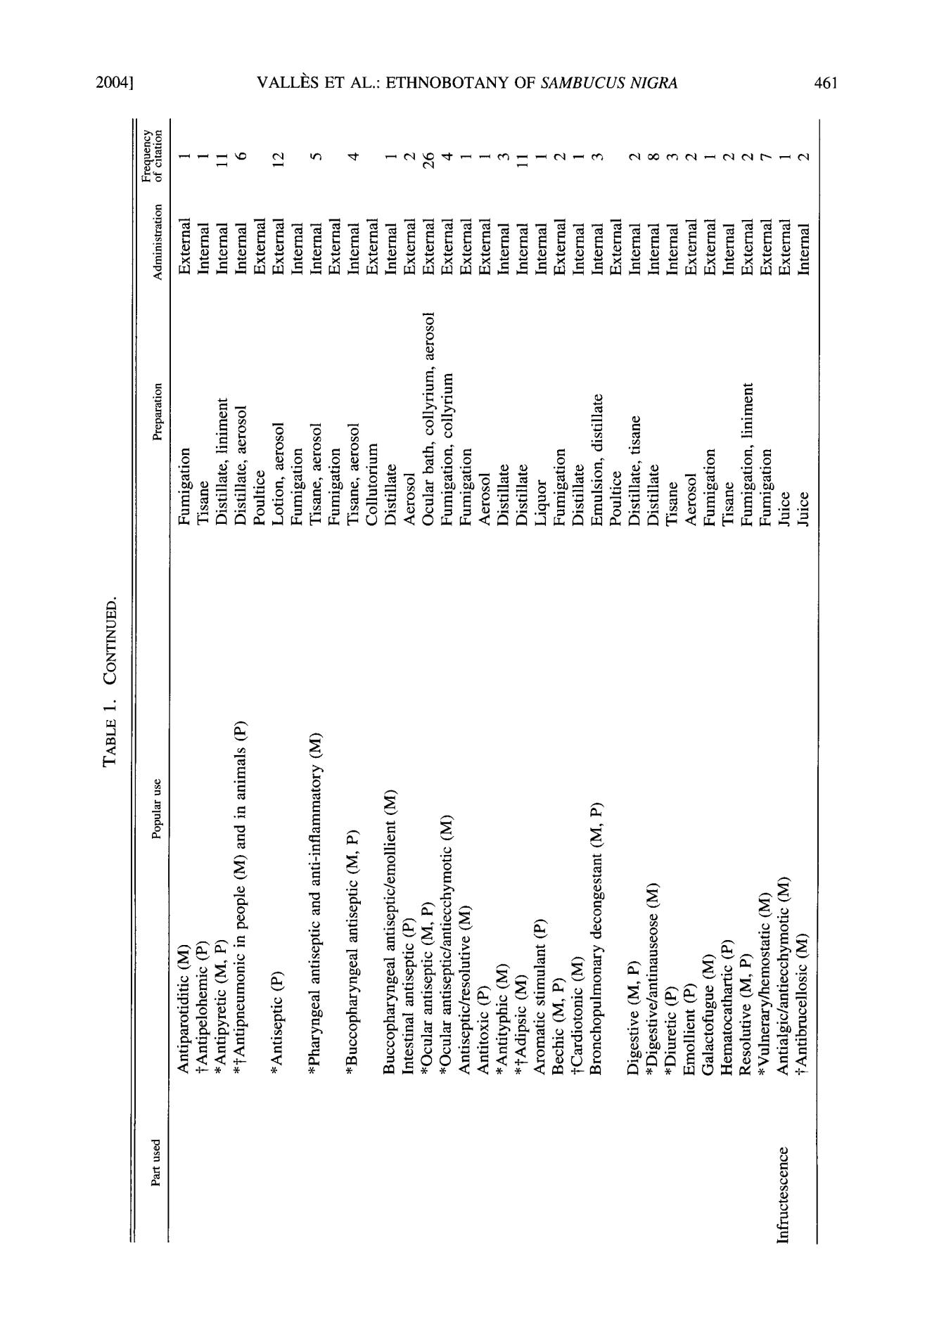**2004]** **VALLI~S ET AL.: ETHNOBOTANY** **OF** ***SAMBUCUS N1GRA*** **461**

|  |  |  |  |  |  |  |  |  |  |  |
| --- | --- | --- | --- | --- | --- | --- | --- | --- | --- | --- |
| **~ o** | **o ~ =** | **" n ~** | **2 o o** | **o o** | **o** | **~** | **d o** | **o** | **o o** |  |
|  | **~n9** | **....** |  | **......** |  |  |
| ,~ = = = o _ ~ . |  | ~ |  | = = |  | = | = = |  |  |  |

U~

Z

9

U~

<

o

**2**

..= **,---.**

" 0

0

o

=9 o .~ ~

|  |  |  |  |  |  |
| --- | --- | --- | --- | --- | --- |
| ~'~ 0.~ ',..~ |  |  |  |  |  |
| 'n = = . < | ~9 ~ | o o ~ = - ~ " | . ~ | ~176 | ~ . ~ |
| ~=<<+- |  |  |  |  |  |

o

o

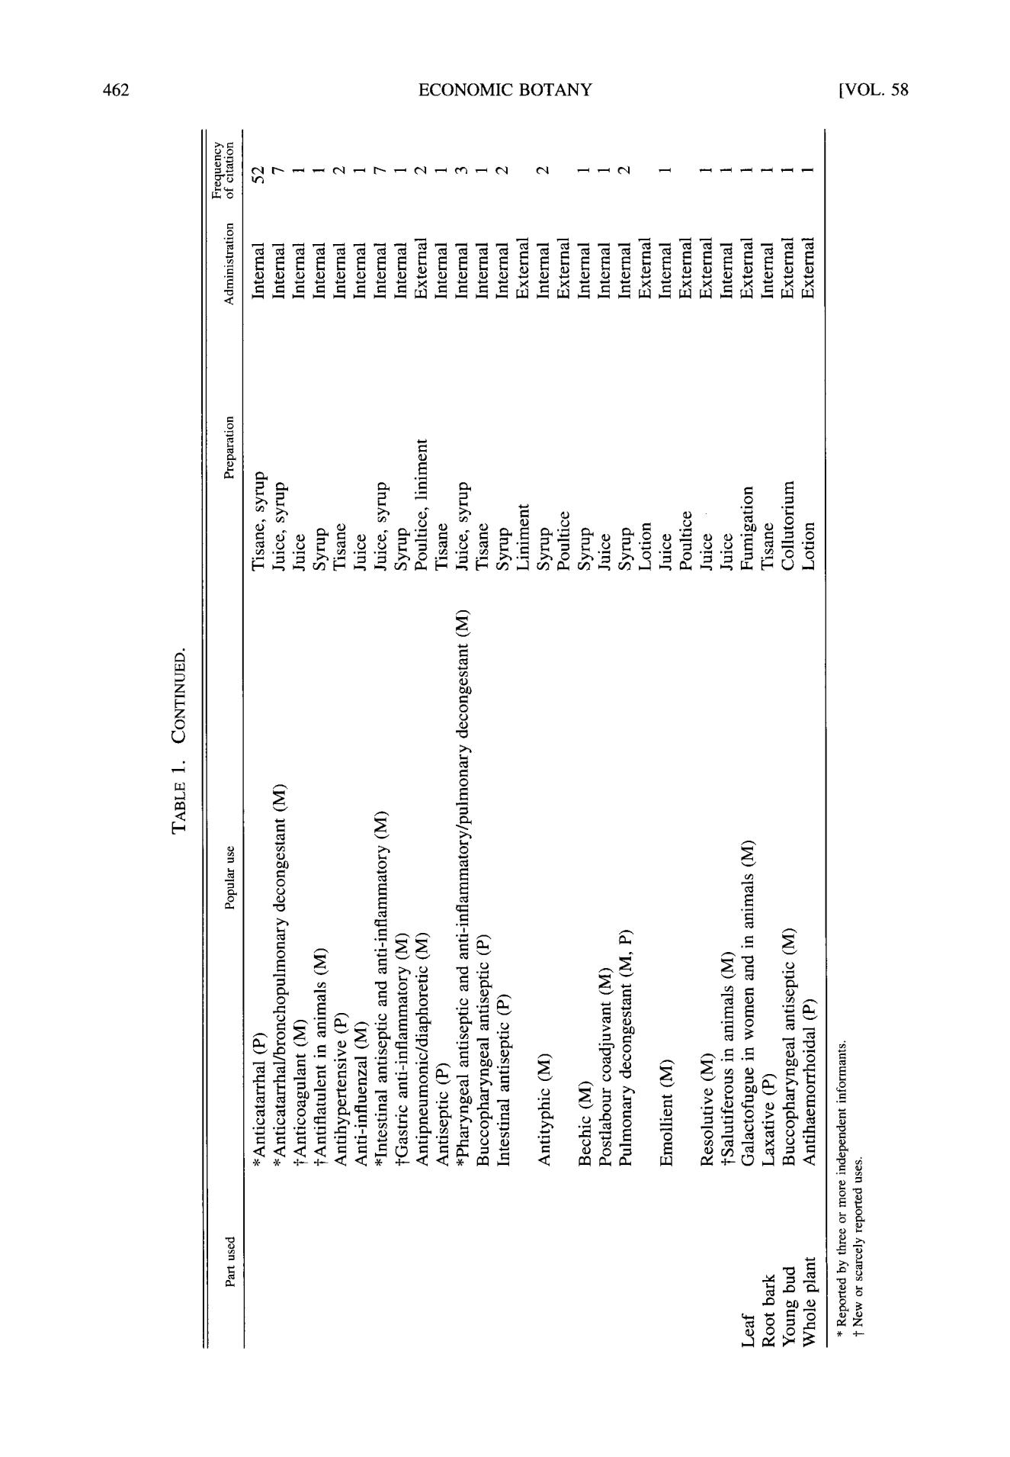462 ECONOMIC BOTANY [VOL. 58

~o

d

U~

Z

|  |  |  |
| --- | --- | --- |
| **z** | 0 |  |
|  |  |
| 9 |  |  |
|  | 0 |  |

|  |  |  |  |
| --- | --- | --- | --- |
| 9 |  |  |  |
|  | o |  |  |
|  |  | ~ o |  |
| **~ ~ N** |  | ~ o ~ |  |
|  | 8 ~ | **i**u~ |  |
|  |  |  |

~ Z

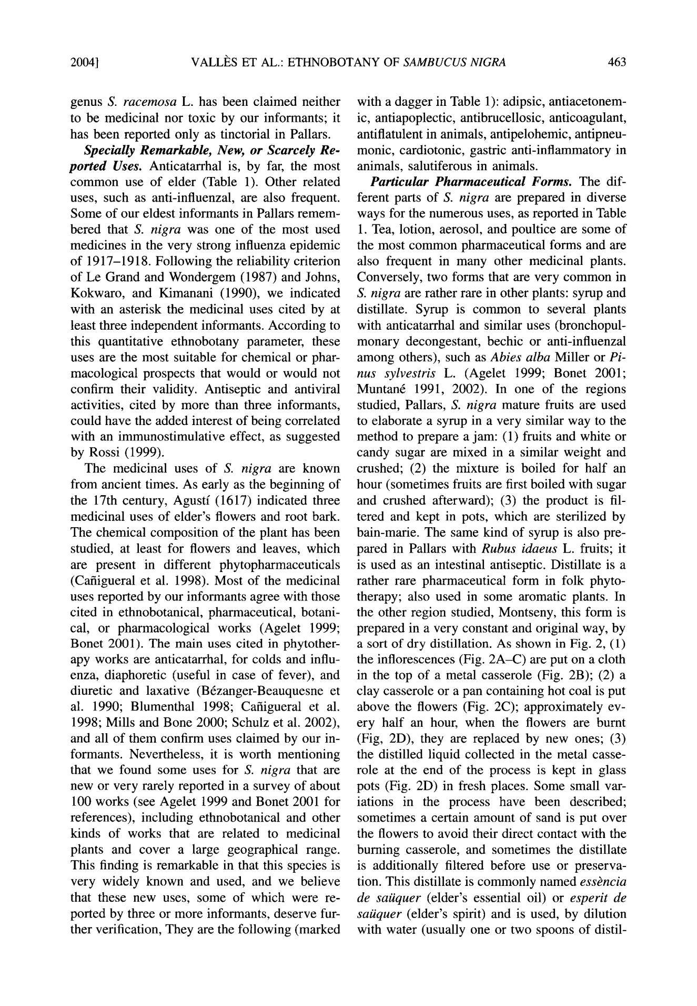2004] VALLI~S ET AL.: ETHNOBOTANY OF *SAMBUCUS NIGRA* 463

genus *S. racemosa* L. has been claimed neither to be medicinal nor toxic by our informants; it has been reported only as tinctorial in Pallars.

*Specially Remarkable, New, or Scarcely Re -*

*ported* *Uses.* Anticatarrhal is, by far, the mostcommo n use o f elder (Table 1). Other related uses, such as anti-influenzal, are also frequent. Some of our eldest informants in Pallars remem - bered that *S. nigra* was one of the most used medicines in the very strong influenza epidemic o f 1917-1918. Following the reliability criterion of Le Grand and Wondergem (1987) and Johns, Kokwaro, and Kimanani (1990), we indicated with an asterisk the medicinal uses cited by at least three independent informants. According to this quantitative ethnobotany parameter, these uses are the most suitable for chemical or phar-macological prospects that would or would not confirm their validity. Antiseptic and antiviral activities, cited by more than three informants, could have the added interest o f being correlated with an immunostimulative effect, as suggested by Rossi (1999).

The medicinal uses o f *S. nigra are* known from ancient times. As early as the beginning of the 17th century, Agustf (1617) indicated three medicinal uses of elder's flowers and root bark. The chemical composition of the plant has been studied, at least for flowers and leaves, which are present in different phytopharmaceuticals (Cafiigueral et al. 1998). Most of the medicinal uses reported by our informants agree with those cited in ethnobotanical, pharmaceutical, botani-cal, or pharmacological works (Agelet 1999; Bonet 2001). The main uses cited in phytother-apy works are anticatarrhal, for colds and influ-enza, diaphoretic (useful in case of fever), and diuretic and laxative (Brzanger - Beauquesne et al. 1990; Blumenthal 1998; Cafiigueral et al. 1998; Mills and Bone 2000; Schulz et al. 2002), and all of them confirm uses claimed by our in-formants. Nevertheless, it is worth mentioning that we found some uses for *S. nigra* that are new or very rarely reported in a survey o f about 100 works (see Agelet 1999 and Bonet 2001 for references), including ethnobotanical and other kinds of works that are related to medicinal plants and cover a large geographical range. This finding is remarkable in that this species is very widely known and used, and we believe that these new uses, some of which were re-ported by three or more informants, deserve fur-ther verification, They are the following (marked

with a dagger in Table 1): adipsic, antiacetonem-ic, antiapoplectic, antibrucellosic, anticoagulant, antiflatulent in animals, antipelohemic, antipneu-monic, cardiotonic, gastric anti - inflammatory in animals, salutiferous in animals.

*Particular Pharmaceutical Forms.* The dif-ferent parts of *S. nigra are* prepared in diverse ways for the numerous uses, as reported in Table

* 1. Tea, lotion, aerosol, and poultice are some of the most commo n pharmaceutical forms and are also frequent in many other medicinal plants. Conversely, two forms that are ver y commo n in *S. nigra are* rather rare in other plants: syrup anddistillate. Syrup is commo n to several plants with anticatarrhal and similar uses (bronchopul-monar y decongestant, bechic or anti-influenzal among others), such as *Abies alba* Miller or *Pi-nus sylvestris* L. (Agelet 1999; Bonet 2001;Muntan6 1991, 2002). In one of the regions studied, Pallars, *S. nigra* mature fruits are used to elaborate a syrup in a very similar way to the method to prepare a jam: (1) fruits and white or candy sugar are mixed in a similar weight and crushed; (2) the mixture is boiled for half an hour (sometimes fruits are first boiled with sugar and crushed afterward); (3) the product is fil-tered and kept in pots, which are sterilized by bain-marie. The same kind o f syrup is also pre-pared in Pallars with *Rubus idaeus* L. fruits; it is used as an intestinal antiseptic. Distillate is a rather rare pharmaceutical form in folk phyto-therapy; also used in some aromatic plants. In the other region studied, Montseny, this form is prepared in a very constant and original way, by a sort of dry distillation. As shown in Fig. 2, (1) the inflorescences (Fig. 2 A - C ) are put on a cloth in the top of a metal casserole (Fig. 2B); (2) a clay casserole or a pan containing hot coal is put above the flowers (Fig. 2C); approximately ev-ery half an hour, when the flowers are bum t (Fig, 2D), they are replaced by new ones; (3) the distilled liquid collected in the metal casse-role at the end of the process is kept in glass pots (Fig. 2D) in fresh places. Some small var-iations in the process have been described; sometimes a certain amount of sand is put over the flowers to avoid their direct contact with the burning casserole, and sometimes the distillate is additionally filtered before use or preserva - tion. This distillate is commonly named *esskncia* *de saiiquer* (elder's essential oil) or *esperit de saiiquer* (elder's spirit) and is used, by dilutionwith water (usually one or two spoons o f distil-

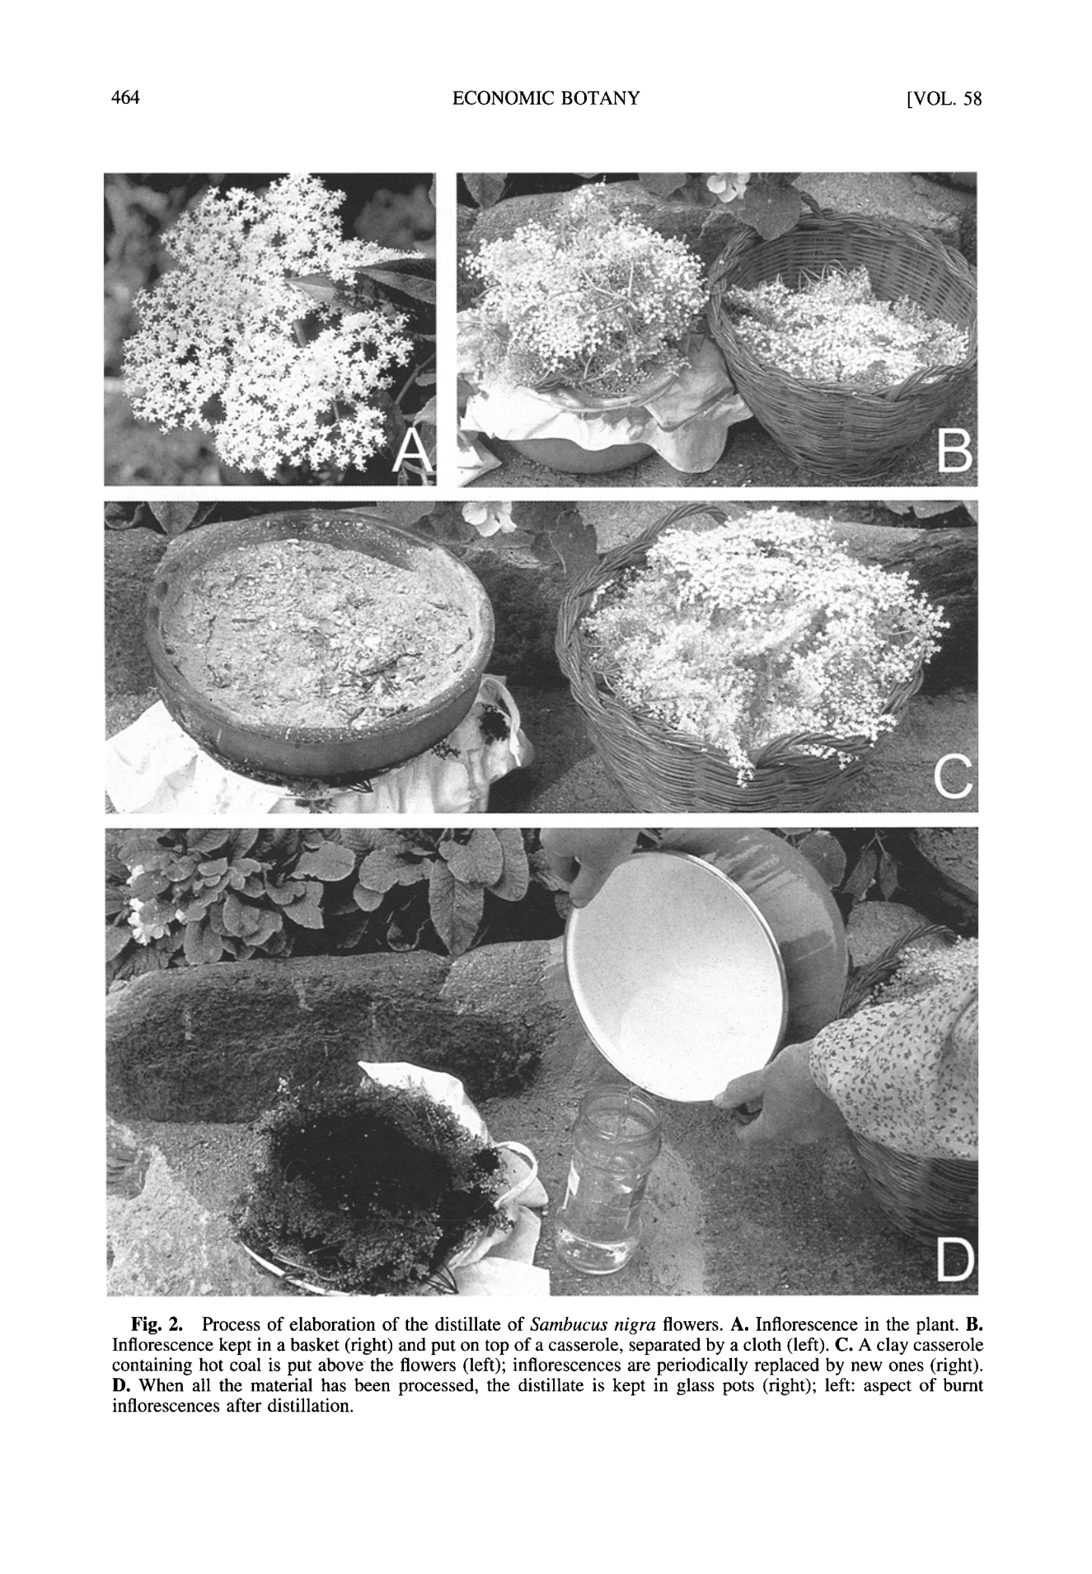464 ECONOMIC BOTANY [VOL. 58

Fig. 2. Process of elaboration of the distillate of *Sambucus nigra* flowers. A. Inflorescence in the plant. B. Inflorescence kept in a basket (right) and put on top of a casserole, separated by a cloth (left). C. A clay casserole containing hot coal is put above the flowers (left); inflorescences are periodically replaced by new ones (right). D. When all the material has been processed, the distillate is kept in glass pots (right); left: aspect of burnt inflorescences after distillation.

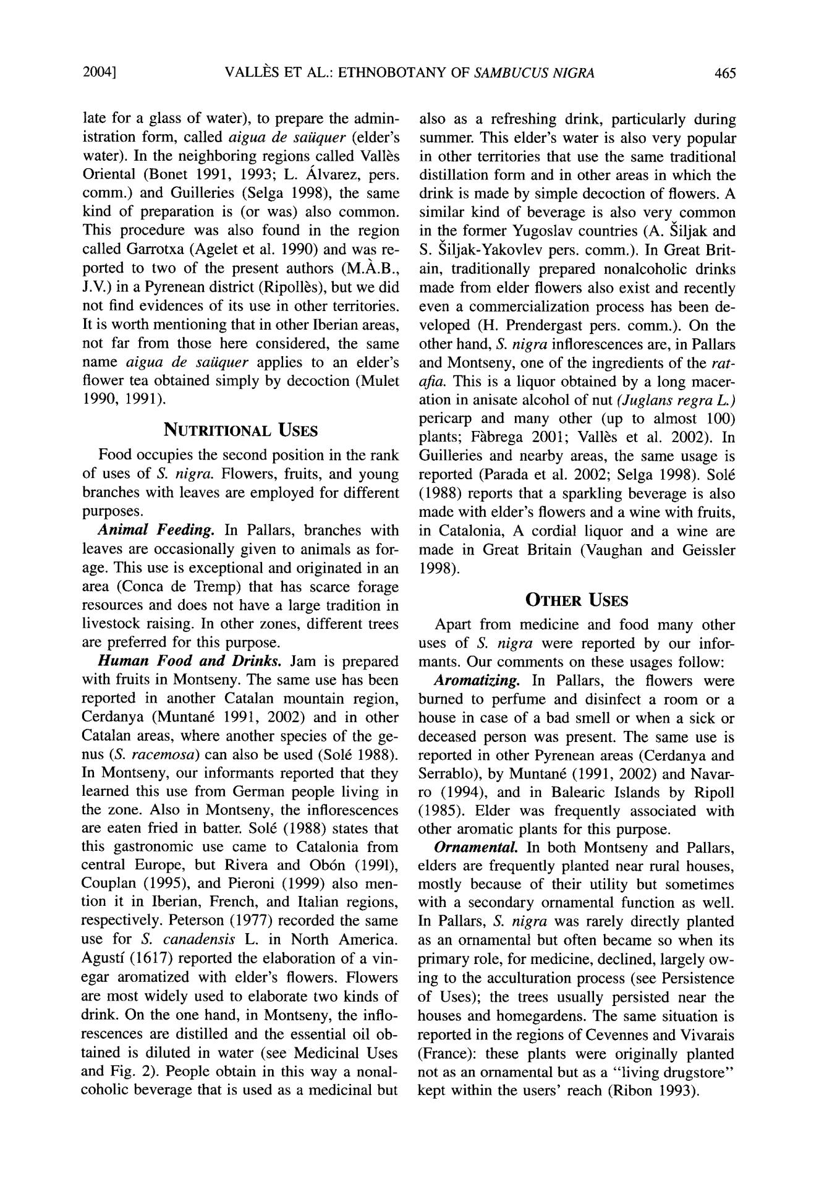2004] VALLI~S ET AL.: ETHNOBOTANY OF *SAMBUCUSN1GRA* 465

late for a glass o f water), to prepare the admin-istration form, called *aigua de saiiquer* (elder's water). In the neighboring regions called Vall~s Oriental (Bonet 1991, 1993; L. ,/dvarez, pers. comm.) and Guilleries (Selga 1998), the same kind of preparation is (or was) also common. This procedure was also found in the region called Garrotxa (Agelet et al. 1990) and was re-ported to two of the present authors (M.,~.B., J.V.) in a Pyrenean district (Ripoll~s), but we did not find evidences of its use in other territories. It is worth mentioning that in other Iberian areas, not far from those here considered, the same name *aigua de saiiquer* applies to an elder's flower tea obtained simply by decoction (Mulet 1990, 1991).

NUTRITIONAL USES

Food occupies the second position in the rank of uses of *S. nigra.* Flowers, fruits, and young branches with leaves are employed for different purposes.

*Animal Feeding.* In Pallars, branches withleaves are occasionally given to animals as for-age. This use is exceptional and originated in an area (Conca de Tremp) that has scarce forage resources and does not have a large tradition in livestock raising. In other zones, different trees are preferred for this purpose.

*Human Food and Drinks.* Jam is preparedwith fruits in Montseny. The same use has been reported in another Catalan mountain region, Cerdanya (Muntan6 1991, 2002) and in other Catalan areas, where another species of the ge-nus *(S. racemosa)* can also be used (So16 1988). In Montseny, our informants reported that they learned this use from German people living in the zone. Also in Montseny, the inflorescences are eaten fried in batter. So16 (1988) states that this gastronomic use came to Catalonia from central Europe, but Rivera and Ob6n (1991), Couplan (1995), and Pieroni (1999) also men-tion it in Iberian, French, and Italian regions, respectively. Peterson (1977) recorded the same use for *S. canadensis* L. in North America. Agustf (1617) reported the elaboration of a vin-egar aromatized with elder's flowers. Flowers are most widely used to elaborate two kinds of drink. On the one hand, in Montseny, the inflo-rescences are distilled and the essential oil ob-tained is diluted in water (see Medicinal Uses and Fig. 2). People obtain in this way a nonal-coholic beverage that is used as a medicinal but

also as a refreshing drink, particularly during summer. This elder's water is also very popular in other territories that use the same traditional distillation form and in other areas in which the drink is made by simple decoction of flowers. A similar kind of beverage is also very common in the former Yugoslav countries (A. Siljak and

1. Siljak-Yakovlev pers. comm.). In Great Brit-ain, traditionally prepared nonalcoholic drinks made from elder flowers also exist and recently even a commercialization process has been de-veloped (H. Prendergast pers. comm.). On the other hand, *S. nigra* inflorescences are, in Pallars and Montseny, one of the ingredients of the *rat-aria.* This is a liquor obtained by a long macer-ation in anisate alcohol of nut *(Juglans regra L.)* pericarp and many other (up to almost 100) plants; F~tbrega 2001; Vall~s et al. 2002). In Guilleries and nearby areas, the same usage is reported (Parada et al. 2002; Selga 1998). So16 (1988) reports that a sparkling beverage is also made with elder's flowers and a wine with fruits, in Catalonia, A cordial liquor and a wine are made in Great Britain (Vaughan and Geissler 1998).

**OTHER USES**

Apart from medicine and food many other uses of *S. nigra* were reported by our infor-mants. Our comments on these usages follow:

*Aromatizing.* In Pallars, the flowers wereburned to perfume and disinfect a room or a house in case of a bad smell or when a sick or deceased person was present. The same use is reported in other Pyrenean areas (Cerdanya and Serrablo), by Muntan6 (1991, 2002) and Navar-ro (1994), and in Balearic Islands by Ripoll (1985). Elder was frequently associated with other aromatic plants for this purpose.

*Ornamental* In both Montseny and Pallars,elders are frequently planted near rural houses, mostly because of their utility but sometimes with a secondary ornamental function as well. In Pallars, *S. nigra* was rarely directly planted as an ornamental but often became so when its primary role, for medicine, declined, largely ow-ing to the acculturation process (see Persistence o f Uses); the trees usually persisted near the houses and homegardens. The same situation is reported in the regions of Cevennes and Vivarais (France): these plants were originally planted not as an ornamental but as a "living drugstore" kept within the users' reach (Ribon 1993).

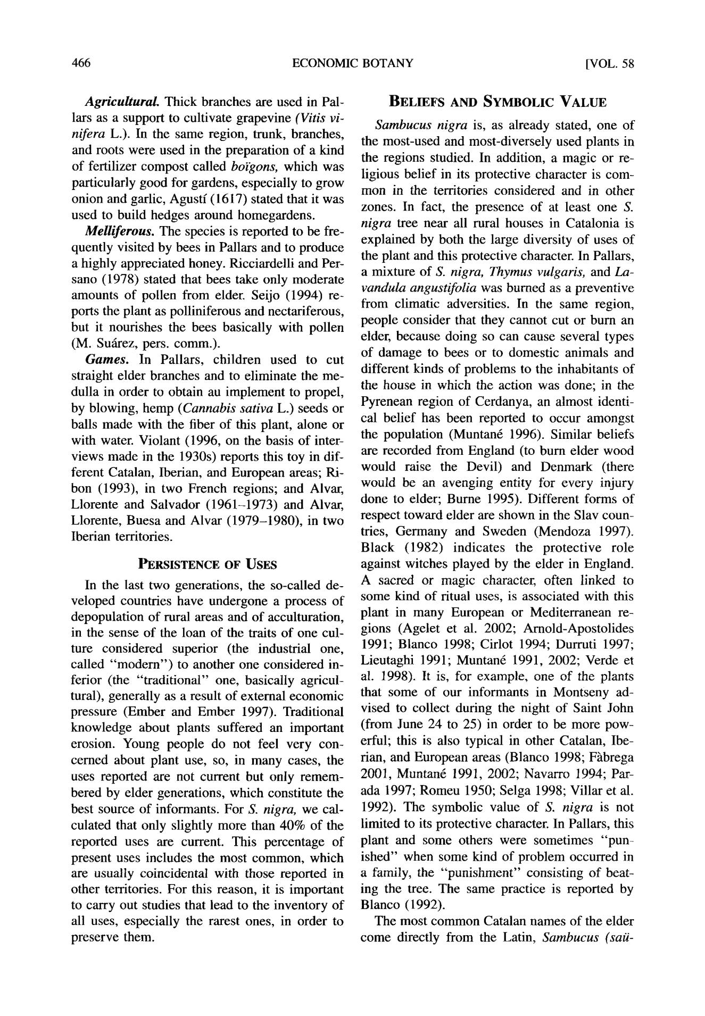466 ECONOMIC BOTANY [VOL. 58

*Agricultural* Thick branches are used in Pal-lars as a support to cultivate grapevine *(Vitis vi-nifera* L.). In the same region, trunk, branches,and roots were used in the preparation of a kind of fertilizer compost called *bo~'gons,* which was particularly good for gardens, especially to grow onion and garlic, Agustf (1617) stated that it was used to build hedges around homegardens.

*MeUiferous. The* species is reported to be fre-quently visited by bees in Pallars and to produce a highly appreciated honey. Ricciardelli and Per-sano (1978) stated that bees take only moderate amounts o f pollen from elder. Seijo (1994) re-ports the plant as polliniferous and nectariferous, but it nourishes the bees basically with pollen (M. Su~ez, pers. comm.).

*Games.* In Pallars, children used to cutstraight elder branches and to eliminate the me-dulla in order to obtain au implement to propel, by blowing, hemp *(Cannabis sativa* L.) seeds or balls made with the fiber of this plant, alone or with water. Violant (1996, on the basis o f inter-views made in the 1930s) reports this toy in dif-ferent Catalan, Iberian, and European areas; Ri-bon (1993), in two French regions; and Alvar, Llorente and Salvador (1961-1973) and Alvar, Llorente, Buesa and Alvar (1979-1980), in two Iberian territories.

**PERSISTENCE OF USES**

In the last two generations, the so-called de-veloped countries have undergone a process o f depopulation of rural areas and o f acculturation, in the sense of the loan of the traits o f one cul-ture considered superior (the industrial one, called " m o d e r n " ) to another one considered in-ferior (the "traditional" one, basically agricul-tural), generally as a result of external economic pressure (Ember and Ember 1997). Traditional knowledge about plants suffered an important erosion. Young people do not feel very con-cerned about plant use, so, in many cases, the uses reported are not current but only remem-bered by elder generations, which constitute the best source o f informants. For *S. nigra,* we cal-culated that only slightly more than 40% of the reported uses are current. This percentage of present uses includes the most common, which are usually coincidental with those reported in other territories. For this reason, it is important to carry out studies that lead to the inventory o f all uses, especially the rarest ones, in order to preserve them.

**BELIEFS AND SYMBOLIC VALUE**

*Sambucus nigra* is, as already stated, one ofthe most-used and most-diversely used plants in the regions studied. In addition, a magic or re-ligious belief in its protective character is com - mon in the territories considered and in other zones. In fact, the presence of at least one S. *nigra* tree near all rural houses in Catalonia isexplained by both the large diversity o f uses of the plant and this protective character. In Pallars, a mixture of *S. nigra, Thymus vulgaris,* and La-*vandula angustifolia* was burned as a preventivefrom climatic adversities. In the same region, people consider that they cannot cut or burn an elder, because doing so can cause several types o f damage to bees or to domestic animals and different kinds o f problems to the inhabitants of the house in which the action was done; in the Pyrenean region of Cerdanya, an almost identi-cal belief has been reported to occur amongst the population (Muntan6 1996). Similar beliefs are recorded from England (to burn elder wood would raise the Devil) and Denmark (there would be an avenging entity for every injury done to elder; Burne 1995). Different forms of respect toward elder are shown in the Slav coun-tries, Germany and Sweden (Mendoza 1997). Black (1982) indicates the protective role against witches played by the elder in England. A sacred or magic character, often linked to some kind o f ritual uses, is associated with this plant in many European or Mediterranean re-gions (Agelet et al. 2002; Arnold-Apostolides 1991; Blanco 1998; Cirlot 1994; Durruti 1997; Lieutaghi 1991; Muntan6 1991, 2002; Verde et al. 1998). It is, for example, one o f the plants that some of our informants in Montseny ad-vised to collect during the night of Saint John (from June 24 to 25) in order to be more pow-erful; this is also typical in other Catalan, Ibe-rian, and European areas (Blanco 1998; F~brega 2001, Muntan6 1991, 2002; Navarro 1994; Par-ada 1997; Romeu 1950; Selga 1998; Villar et al. 1992). The symbolic value o f *S. nigra* is not limited to its protective character. In Pallars, this plant and some others were sometimes "pun - ished" when some kind of problem occurred in a family, the "punishment" consisting o f beat-ing the tree. The same practice is reported by Blanco (1992).

The most commo n Catalan names of the elder come directly from the Latin, *Sambucus (saii-*

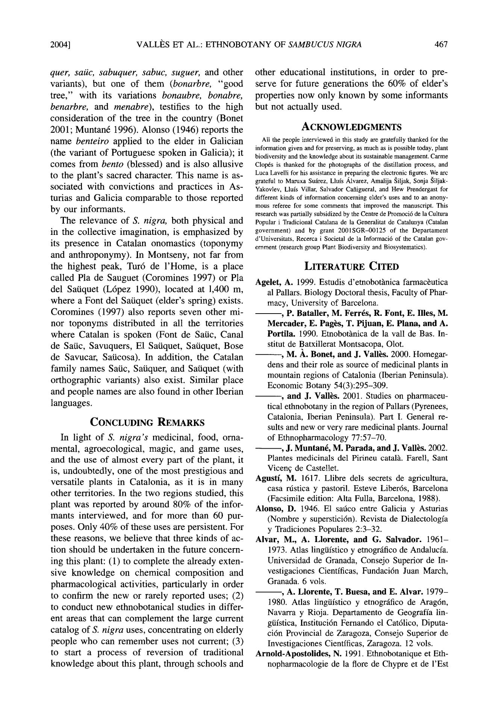2004] VALLI~S ET AL.: ETHNOBOTANY OF *SAMBUCUSN1GRA* 467

*quer, saiic, sabuquer, sabuc, suguer,* and othervariants), but one o f them *(bonarbre,* " g o o d tree," with its variations *bonaubre, bonabre,* *benarbre, and menabre),* testifies to the highconsideration of the tree in the country (Bonet 2001; Muntan6 1996). Alonso (1946) reports the name *benteiro* applied to the elder in Galician (the variant o f Portuguese spoken in Galicia); it comes from *bento* (blessed) and is also allusive to the plant's sacred character. This name is as-sociated with convictions and practices in As - turias and Galici a comparable to those reported by our informants.

The relevance of *S. nigra,* both physical and in the collective imagination, is emphasized by its presence in Catalan onomastics (toponymy and anthroponymy) . In Montseny, not far from the highest peak, Tur6 de l'Home , is a place called Pla de Sauguet (Coromines 1997) or Pla del Satiquet (L6pez 1990), located at 1,400 m, where a Font del Satiquet (elder's spring) exists. Coromines (1997) also reports seven other mi-nor toponyms distributed in all the territories where Catalan is spoken (Font de Satic, Canal de Satic, Savuquers, E1 Satiquet, Satiquet, Bose de Savucar, Saticosa). In addition, the Catalan family names Satic, Satiquer, and Satiquet (with orthographic variants) also exist. Similar place and people names are also found in other Iberian languages.

CONCLUDING REMARKS

In light o f *S. nigra's* medicinal, food, orna-mental, agroecological, magic, and game uses, and the use o f almost every part of the plant, it is, undoubtedly, one o f the most prestigious and versatile plants in Catalonia, as it is in many other territories. In the two regions studied, this plant was reported by around 80% of the infor-mants interviewed, and for more than 60 pur-poses. Only 40% o f these uses are persistent. F o r these reasons, we believe that three kinds of ac-tion should be undertaken in the future concern-ing this plant: (1) to complete the already exten-sive knowledge on chemical composition and pharmacological activities, particularly in order to confirm the new or rarely reported uses; (2) to conduct new ethnobotanical studies in differ-ent areas that can complement the large current catalog of *S. nigra* uses, concentrating on elderly people who can remembe r uses not current; (3) to start a process of reversion o f traditional knowledge about this plant, through schools and

other educational institutions, in order to pre-serve for future generations the 60% of elder's properties now only known by some informants but not actually used.

ACKNOWLEDGMENTS

All the people interviewed in this study are gratefully thanked for the information given and for preserving, as much as is possible today, plant biodiversity and the knowledge about its sustainable management. Carme Cloprs is thanked for the photographs of the distillation process, and Luca Lavelli for his assistance in preparing the electronic figures. We arc grateful to Maruxa Su~rez, Llufs ~.lvarez, Amalija Siljak, Sonja Siljak-Yakovlev, Llufs Villar, Salvador Cafiigueral, and Hew Prendergast for different kinds of information concerning elder's uses and to an anony-mous referee for some comments that improved the manuscript. This research was partially subsidized by the Centre de Promoci6 de la Cultura Popular i Tradicional Catalana de la Generalitat de Catalunya (Catalan government) and by grant 2001SGR-00125 of the Departament d'Universitats, Recerca i Societal de la lnformaci6 of the Catalan gov-ernment (research group Plant Biodiversity and Biosystematics).

LITERATURE CITED

**Agelet,** A. 1999. Estudis d'etnobothnica farmac~uticaal Pallars. Biology Doctoral thesis, Faculty of Phar-macy, University of Barcelona.

* + **P. Bataller, M. Ferrrs, R. Font, E. Ilies, M. Mereader, E. Pages, T. Pijuan, E. Plana, and A. Portila.** 1990. Etnobothnica de la vail de Bas. In-stitut de Batxillerat Montsacopa, Olot.
  + M. ~,. **Bonet, and** J. Vall~s. 2000. Homegar-dens and their role as source of medicinal plants in mountain regions of Catalonia (Iberian Peninsula). Economic Botany 54(3):295-309.
  + and J. Vallbs. 2001. Studies on pharmaceu-tical ethnobotany in the region of Pallars (Pyrenees, Catalonia, Iberian Peninsula). Part I. General re-suits and new or very rare medicinal plants. Journal of Ethnopharmacology 77:57-70.
* J. Muntanr, M. **Parada, and** J. Vall~s. 2002. Plantes medicinals del Pirineu catalh. Farell, Sant Vicenff de Castellet.

**Agustf,** M. 1617. Llibre dels secrets de agricultura, casa rtistica y pastoril. Esteve Liber6s, Barcelona (Facsimile edition: Alta Fulla, Barcelona, 1988).

**Alonso,** D. 1946. E1 satico entre Galicia y Asturias(Nombre y supersticirn). Revista de Dialectologfa y Tradiciones Populares 2:3-32.

**Alvar,** **M., A. Llorente, and G. Salvador.** 1961-1973. Atlas lingtifstico y etnogr~ifico de Andalucfa. Universidad de Granada, Consejo Superior de In-vestigaciones Cientfficas, Fundaci6n Juan March, Granada. 6 vols.

* A. Llorente, T. Buesa, and E. Alvar. 1979-1980. Atlas lingtifstico y etnogrfifico de Arag6n, Navarra y Rioja. Departamento de Geograffa lin-gtifstica, Instituci6n Fernando el Cat61ico, Diputa-ci6n Provincial de Zaragoza, Consejo Superior de Investigaciones Cientfficas, Zaragoza. 12 vols.

**Arnold-Apostolides,** N. 1991. Ethnobotanique et Eth-nopharmacologie de la tore de Chypre et de l'Est

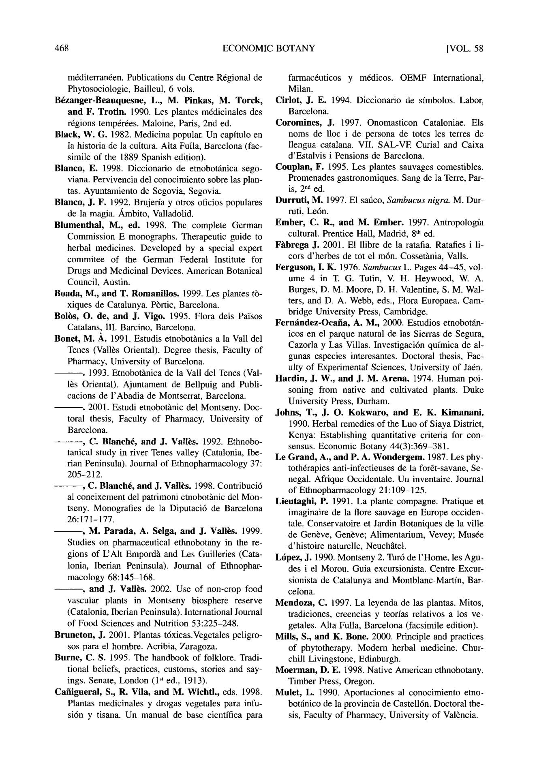468 ECONOMIC BOTANY [VOL. 58

mrditerranren. Publications du Centre Rrgional de Phytosociologie, Bailleul, 6 vols.

**B~zanger-Beauquesne, L., M. Pinkas, M. Torck,**

**and F. Trotin.** 1990. Les plantes mrdicinales desrrgions temprrres. Maloine, Paris, 2nd ed.

Black, W. G. 1982. Medicina popular. Un capflulo en la historia de la cultura. Alta Fulla, Barcelona (fac-simile of the 1889 Spanish edition).

Blanco, E. 1998. Diccionario de etnobot~inica sego-viana. Pervivencia del conocimiento sobre las plan-tas. Ayuntamiento de Segovia, Segovia.

**Blaneo,** J . F. 1992, Brujerfa y otros oficios popularesde la magia. ,~mbito, Valladolid.

**Blumenthal,** **M., ed.** 1998. The complete GermanCommission E monographs. Therapeutic guide to herbal medicines. Developed by a special expert commitee of the German Federal Institute for Drugs and Medicinal Devices. American Botanical Council, Austin.

**Boada, M., and** T. Romaniilos. 1999. Les plantes tr -xiques de Catalunya. Prrtic, Barcelona.

Bolbs, O. **de, and J. Vigo.** 1995. Flora dels Pa'isos Catalans, III. Barcino, Barcelona.

Bouet, M. A,. 1991. Estudis etnobot~nics a la Vail del Tenes (Vall~s Oriental). Degree thesis, Faculty of Pharmacy, University of Barcelona.

- - . 1993. Etnobot~nica de la Vall del Tenes (Val-Its Oriental). Ajuntament de Bellpuig and Publi-cacions de l'Abadia de Montserrat, Barcelona.

- - . 2001. Estudi etnobot~nic del Montseny. Doc-toral thesis, Faculty of Pharmacy, University of Barcelona.

- - , C. Blanchr, and J. Vall~s. 1992. Ethnobo-tanical study in river Tenes valley (Catalonia, Ibe-rian Peninsula). Journal of Ethnopharmacology 37: 205-212.

* - ,C. **Blanche, and J. Vall~s.** 1998. Contribuci6 al coneixement del patrimoni etnobot~nic del Mon-tseny. Monografies de la Diputaci6 de Barcelona 26:171-177.
* - ,**M. Parada, A. Selga, and J. Vall~s.** 1999.Studies on pharmaceutical ethnobotany in the re-gions of L'Alt Empord~ and Les Guilleries (Cata-lonia, Iberian Peninsula). Journal of Ethnophar-macology 68:145-168.
* - ,and J. Vall~s. 2002. Use of non-crop food vascular plants in Montseny biosphere reserve (Catalonia, Iberian Peninsula). International Journal

of Food Sciences and Nutrition 53:225-248. **Bruueton,** J. 2001. Plantas t6xicas.Vegetales peligro-

sos para el hombre. Acribia, Zaragoza.

**Burne,** C. S. 1995. The handbook of folklore. Tradi-tional beliefs, practices, customs, stories and say-ings. Senate, London (1S' ed., 1913).

**Cafiigueral, S., R. Vila, and M. Wichtl.,** eds. 1998.Plantas medicinales y drogas vegetales para infu-sirn y tisana. Un manual de base cientffica para

farmacruticos y mrdicos. OEMF International, Milan.

Cirlot, J. E. 1994. Diccionario de sfmbolos. Labor, Barcelona.

**Coromines,** J. 1997. Onomasticon Cataloniae. Els noms de lloc i de persona de totes les terres de llengua catalana. VII. SAL-VE Curial and Caixa d'Estalvis i Pensions de Barcelona.

**Couplan,** F. 1995. Les plantes sauvages comestibles.Promenades gastronomiques. Sang de la Terre, Par-is, 2 nd ed.

**Durruti,** M. 1997. E1 safico,*Sambucus nigra.*M. Dur-ruti, Lern.

**Ember,** C, R., and M. Ember . 1997. Antropologia cultural. Prentice Hall, Madrid, 8 ~ ed.

**Fhbrega** J . 2001. E1 llibre de la ratafia. Ratafies i li-cors d'herbes de tot el mrn. Cossetb~nia, Vails.

**Ferguson,** I. K. 1976.*Sambucus*L. Pages 44-45, vol-ume 4 in T. G. Tutin, V. H. Heywood, W. A. Burges, D. M. Moore, D. H. Valentine, S. M. Wai-ters, and D. A. Webb, eds., Flora Europaea. Cam-bridge University Press, Cambridge.

Fern,'indez-Ocafia, A. M., 2000. Estudios etnobotfin-icos en el parque natural de las Sierras de Segura, Cazorla y Las Villas. Investigacirn qufmica de al-gunas especies interesantes. Doctoral thesis, Fac-ulty of Experimental Sciences, University of Jarn.

**Hardin,** J. W., and J. M. Arena, 1974. Human poi-soning from native and cultivated plants. Duke University Press, Durham.

**Johns, T., J. O. Kokwaro, and E. K. Kimanani.**

1990. Herbal remedies of the Luo of Siaya District, Kenya: Establishing quantitative criteria for con-sensus. Economic Botany 44(3):369-381.

**Le Grand, A., and** P. A. Wondergem . 1987. Les phy-tothrrapies anti-infectieuses de la for~t-savane, Se-negal. Afrique Occidentale. Un inventaire. Journal of Ethnopharmacology 21:109-125.

**Lieutaghi,** P. 1991. La plante compagne. Pratique etimaginaire de la tor e sauvage en Europe occiden-tale. Conservatoire et Jardin Botaniques de la ville de Gen~ve, Gen~ve; Alimentarium, Vevey; Mus~e d'histoire naturelle, Neuch~tel.

Lrpez, J. 1990. Montseny 2. Tur6 de l'Home, les Agu-des i el Morou. Guia excursionista. Centre Excur-sionista de Catalunya and Monthlanc-Martfn, Bar-celona.

**Mendoza,** C. 1997. La leyenda de las plantas. Mitos,tradiciones, creencias y teorfas relativos a los ve-getales. Alta Fulla, Barcelona (facsimile edition).

Mills, S., and K. Bone. 2000. Principle and practices of phytotherapy. Modern herbal medicine. Chur-chill Livingstone, Edinburgh.

**Moerman,** D. E, 1998. Native American ethnobotany.

Timber Press, Oregon.

Mulet, L. 1990. Aportaciones al conocimiento etno-botfinico de la provincia de Castell6n. Doctoral the-sis, Faculty of Pharmacy, University of Valencia.

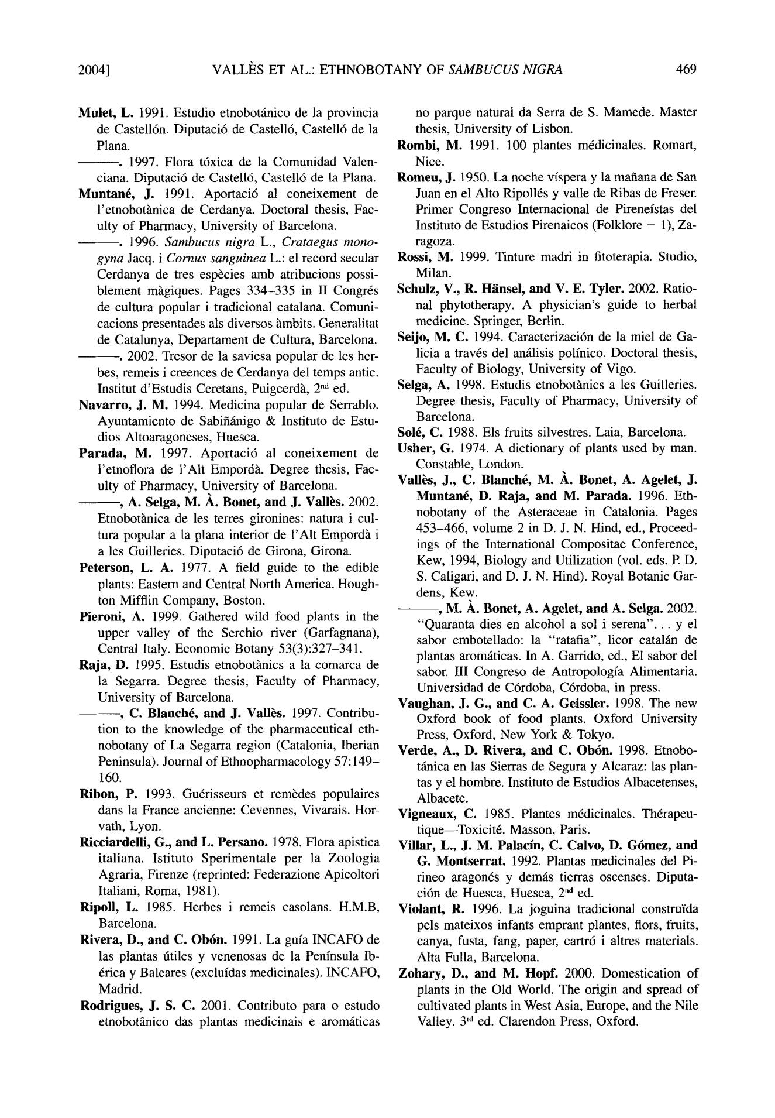2004] VALLI~S ET AL.: ETHNOBOTANY OF *SAMBUCUS NIGRA* 469

Mulet, L. 199I. Estudio etnobot~inico de la provincia de Castell6n. Diputaci6 de Castell6, Castell6 de la Plana.

9 1997. Flora t6xica de la Comunidad Valen-ciana. Diputaci6 de Castell6, Castell6 de la Plana.

**Muntan6,** J. 1991. Aportaci6 al coneixement de l'etnobot~nica de Cerdanya. Doctoral thesis, Fac-ulty of Pharmacy, University of Barcelona.

- - . 1996. *Sambucus nigra L., Crataegus mono-gyna* Jacq. i *Comus sanguinea* L.: el record secularCerdanya de tres esp~cies amb atribucions possi-blement m~tgiques. Pages 334-335 in II Congr6s de cultura popular i tradicional catalana. Comuni-cacions presentades als diversos ~mbits. Generalitat de Catalunya, Departament de Cultura, Barcelona.

- - . 2002. Tresor de la saviesa popular de les her-bes, remeis i creences de Cerdanya del temps antic. Institut d'Estudis Ceretans, Puigcerd~, 2 "a ed.

**Navarro,** J. M. 1994. Medicina popular de Serrablo.Ayuntamiento de Sabifi~inigo & Instituto de Estu-dios Altoaragoneses, Huesca.

**Parada,** M. 1997. Aportaci6 al coneixement de l'etnoflora de l'Alt Empord~t. Degree thesis, Fac-ulty of Pharmacy, University of Barcelona.

* **A. Selga, M. ~.. Bonet, and** J. Vall~s. 2002.Etnobot~mica de les terres gironines: naturai cul-tura popular a la plana interior de l'Alt Empord~ i a les Guilleries. Diputaci6 de Girona, Girona.

**Peterson,** L. A. 1977. A field guide to the edible plants: Eastern and Central North America. Hough-ton Mifflin Company, Boston.

**Pieroni,** A. 1999. Gathered wild food plants in theupper valley of the Serehio river (Garfagnana), Central Italy. Economic Botany 53(3):327-341.

Raja, D. 1995. Estudis etnobot~nics a la comarca de la Segarra. Degree thesis, Faculty of Pharmacy, University of Barcelona.

* C. **BlanchC and** J. Vall~s. 1997. Contribu-tion to the knowledge of the pharmaceutical eth-nobotany of La Segarra region (Catalonia, Iberian Peninsula). Journal of Ethnopharmacology 57:149-160.

Ribon, P. 1993. Gu6risseurs et rem~des populaires dans la France ancienne: Cevennes, Vivarais. Hor-vath, Lyon.

**Ricciardelli, G., and L. Persano.** 1978. Flora apisticaitaliana. Istituto Sperimentale per la Zoologia Agraria, Firenze (reprinted: Federazione Apicoltori Italiani, Roma, 1981).

Ripoll, L. 1985. Herbes i remeis casolans. H.M.B, Barcelona.

**Rivera, D., and C. Ob6n.** 1991. La gufa INCAFO delas plantas riffles y venenosas de la Penfnsula Ib-6rica y Baleares (excluldas medicinales). INCAFO, Madrid.

**Rodrigues,** J. S. C. 2001. Contributo para o estudoetnobot~nico das plantas medicinais e aromfiticas

no parque natural da Serra de S. Mamede. Master thesis, University of Lisbon.

Rombi, M. 1991. 100 plantes m6dicinales. Romart, Nice.

**Romeu, J.** 1950. La noche vfspera y la mafiana de SanJuan en el Alto Ripoll6s y valle de Ribas de Freser. Primer Congreso Internacional de Pireneistas del Instituto de Estudios Pirenaicos (Folklore - 1), Za-ragoza.

Rossi, M. 1999. Tinture madri in fitoterapia. Studio, Milan.

**Sehulz, V., R. H[insel, and V. E. Tyler 9**2002. Ratio-nal phytotherapy. A physician's guide to herbal medicine. Springer, Berlin.

Seijo, M. C, 1994. Caracterizaci6n de la miel de Ga-licia a trav6s del amilisis polfnico. Doctoral thesis, Faculty of Biology, University of Vigo.

**Selga,** A. 1998. Estudis etnobot~nics a l e s Guilleries.Degree thesis, Faculty of Pharmacy, University of Barcelona.

So16, C. 1988. Els fruits silvestres. Laia, Barcelona.

**Usher,** G. 1974. A dictionary of plants used by man.

Constable, London.

**Vall~s, J., C. Blanche, M. A.. Bonet, A. Agelet, J. Muntan~, D. Raja, and M. Parada.** 1996. Eth-nobotany of the Asteraceae in Catalonia. Pages 453-466, volume 2 in D. J. N. Hind, ed., Proceed-ings of the International Compositae Conference, Kew, 1994, Biology and Utilization (vol. eds. R D. S. Caligari, and D. J. N. Hind). Royal Botanic Gar-dens, Kew.

* **M. A. Bonet, A. Agelet, and A. Selga.** 2002."Quaranta dies en alcohol a sol i serena" .. , y el sabot embotellado: la "ratafia", licor catal~in de plantas arom~iticas. In A. Garrido, ed., E1 sabot del sabor. III Congreso de Antropologfa Alimentaria. Universidad de C6rdoba, C6rdoba, in press.

**Vaughan,** J. G., and C. A. Geissler. 1998. The newOxford book of food plants. Oxford University Press, Oxford, New York & Tokyo.

**Verde, A., D. Rivera, and C. Ob6n.** 1998. Etnobo-t~inica en las Sierras de Segura y Alcaraz: las plan-tas y el hombre. Instituto de Estudios Albacetenses, Albacete.

**Vigneaux,** C. 1985. Plantes m6dicinales. Th6rapeu-tique Toxicit6. Masson, Paris.

**Villar, L., J. M. Palacin, C. Calvo, D. G6mez, and**

1. Montserrat . 1992. Plantas medicinales del Pi-rineo aragon6s y demos tierras oscenses. Diputa-ci6n de Huesca, Huesca, 2 "ded.

**Violant,** R. 1996. La joguina tradicional construida pels mateixos infants emprant plantes, flors, fruits, canya, fnsta, fang, paper, cartr6 i altres materials. Alta Fulla, Barcelona.

Zohary, D., and M, Hopf. 2000. Domestication of plants in the Old World. The origin and spread of cultivated plants in West Asia, Europe, and the Nile Valley. 3 rd ed. Clarendon Press, Oxford.